OXYGEN ACTIVE GRANULAR.
Chlorine-fee treatment. oxidant used to remove organic matter (sweat, body oils and other wastes..) and destroys nitrogenous compounds. It helps neutralize unpleasant odors and unwanted smell in the water, so all this contributes to the improvement and clarification of the pool water.
Instructions of use and aplication: Add at the rate of: Start up: 1 kg/ 50 m3. Maintenance: 700 g/ 50 m3/ weekly. Application by professional personnel.
Composition: Pentapotassium bis (peroxymonosulphate) bis (sulphate) 1000 g/Kg. (CAS: 70693-62-8)
Hazard statements: H272: May intensify fire; oxidiser. H302: Harmful if swallowed.H314: Causes severe skin burns and eye damage. H334: May cause allergy or asthma symptoms or breathing difficulties if inhalation. H317: May cause an allergic skin reaction. H412: Harmful to aquatic life with long lasting effects.
Precautionary statements: P102+ P405: Keep out of the reach of children. Save under lock and key. P221+P210: Take any precaution to avoid mixing with combustibles. Keep away from heat, hot surfaces from sparks, open flames and all other sources of ignition. No Smoking. P270+P260: Do not eat, drink or smoke during use. Avoid breathing dust. P273: Avoid release to the environment. P280+P264+P363: Wear protective gloves / clothing / eye protection / face protection. Wash thoroughly after handling. Wash contaminated clothing before reuse. P370+P378:In case of fire: Use water in bulk to turn it off. P501: Dispose of contents/container to in accordance with hazardous waste regulations.
Recommendations for cases of intoxication or accident: In contact with eyes, wash with plenty of water for at least 15 minutes. Don't forget to remove the lenses. In contact with the skin, wash with plenty of soap and water without rubbing. In case of ingestion: DO NOT induce vomiting.. If the person is unconscious, lie on their side with their head lower than the rest of the body and their knees semi-bent. If necessary, transfer the poisoned person to a health centre, and whenever possible carry the label or packaging. DO NOT LEAVE THE INTOXICATED ALONE IN ANY CASE. IF MEDICAL ADVICE IS NEEDED, KEEP THE LABEL OR CONTAINER HANDY

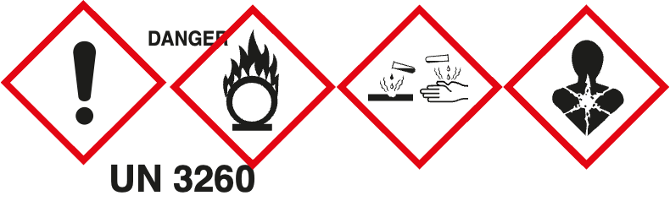
EXPIRATION: 2 years from packaging date (see date on packaging)
UFI: D7J5-60V9-G00Y-SKAY
Manufactured by: PRODUCTOS QP, S.A.Ctra. Logroño, Km.10,200 50180 UTEBO (Zaragoza) Tel. +34 976 78 64 64
www.productosqp.com

Content:
Manufacturing date:

